Data Analysis Report
(Assignment)

Dated: 18-03-2026
Table of Contents
Acknowledgement
Steps of Data Analysis
- Introduction
- Import Libraries
- Load Dataset
- Dataset Understanding
  - Exploratory Data Analysis (EDA)
5.1 Feature Relationship Analysis (Correlation Insight)
5.2 Data Distribution Visualization
5.3 Outlier Detection
  - Data Cleaning & Preprocessing
6.1 Handling Missing Values
6.2 Mean Values of Every Column
6.3 Filling Missing Values with Mean
  - Feature & Target Selection
  - Data Normalization
  - Regression Model (Linear Regression)
10. Prediction
11. Error Report
- Mean Squared Error (MSE)
- Root Mean Squared Error (RMSE)
- Mean Absolute Error (MAE)
- R² Score
12.Actual vs Predicted Analysis
13.Predictive Analysis (Feature Importance)
14.Conclusion

Acknowledgement:
I would like to express my sincere gratitude and appreciation to Dr. Iltaf Khan for his invaluable technical guidance, mentorship, and professional oversight throughout the duration of this project. His extensive expertise in medical measurement analysis was instrumental in shaping the theoretical framework and ensuring the clinical relevance of the predictive models developed within this report.
This report reflects a rigorous commitment to data integrity, from the initial exploratory phase to the final validation of the Linear Regression model. The insights gained from this analysis, particularly regarding the estimation of the fractal_dimension_worst variable, were made possible through the academic environment and standards fostered under his supervision.

Aiza Iqbal
(Data Analyst & Web Developer)

Steps:
1.Introduction:
This report presents a comprehensive data analysis and predictive modeling study using a structured dataset related to medical measurements. The main objective of this analysis is to explore the dataset, understand the relationships between different features, and build a machine learning model to predict the target variable, fractal_dimension_worst.
The analysis begins with data loading and understanding, followed by Exploratory Data Analysis (EDA) to identify patterns, trends, and correlations among variables. Special attention is given to detecting missing values, understanding data distribution, and identifying outliers to ensure data quality.
After preprocessing and cleaning the dataset, a Linear Regression model is applied to establish a relationship between input features and the target variable. The model is then evaluated using standard performance metrics such as Mean Squared Error (MSE), Root Mean Squared Error (RMSE), Mean Absolute Error (MAE), and R² Score.
Furthermore, predictive analysis is conducted to determine the importance of different features in influencing the target variable. The comparison between actual and predicted values helps assess the accuracy and reliability of the model.
Overall, this report demonstrates how data analysis techniques and machine learning algorithms can be effectively used to extract meaningful insights and make accurate predictions from real-world data.
2. Import Libraries:
In this step, essential Python libraries were imported to perform data analysis, visualization, and machine learning tasks.
- Pandas was used for data manipulation and handling datasets.
- NumPy was used for numerical computations.
- Matplotlib was used for data visualization.
- Scikit-learn (sklearn) was used for implementing machine learning models.
This step is important because these libraries provide the tools required for processing, analyzing, and modeling the dataset efficiently.

Python code:
import pandas as pd
import numpy as np
from sklearn.model_selection import train_test_split
from sklearn.linear_model import LinearRegression
from sklearn.metrics import mean_squared_error, mean_absolute_error, r2_score
import matplotlib.pyplot as plt

Purpose of this Step:
• Prepare the programming environment
• Enable data analysis and visualization
• Support regression modeling workflow

3. Load Dataset:
The dataset was loaded into Python using the Pandas library.
- The dataset file (data_for regression.csv) was read using pd.read_csv().
- The data was stored in a DataFrame named df.
- The first few rows were displayed using df.head() to understand the structure.
This step helps in verifying that the dataset is correctly loaded and gives an initial view of the data.
Python code:
# Load dataset
df = pd.read_csv("data_for regression.csv")
df.head()
Purpose of this Step:
• Import raw data into the analysis environment
• Convert data into structured tabular format
• Prepare data for exploration and regression modeling

4. Dataset Understanding:
In this step, the structure and basic information of the dataset were examined.
- df.shape was used to check the number of rows and columns (569 rows and 30 features).
- df.info() provided details about data types and missing values.
- df.describe() generated statistical summaries such as mean, standard deviation, minimum, and maximum values.
This step is crucial for understanding the dataset before performing any analysis.

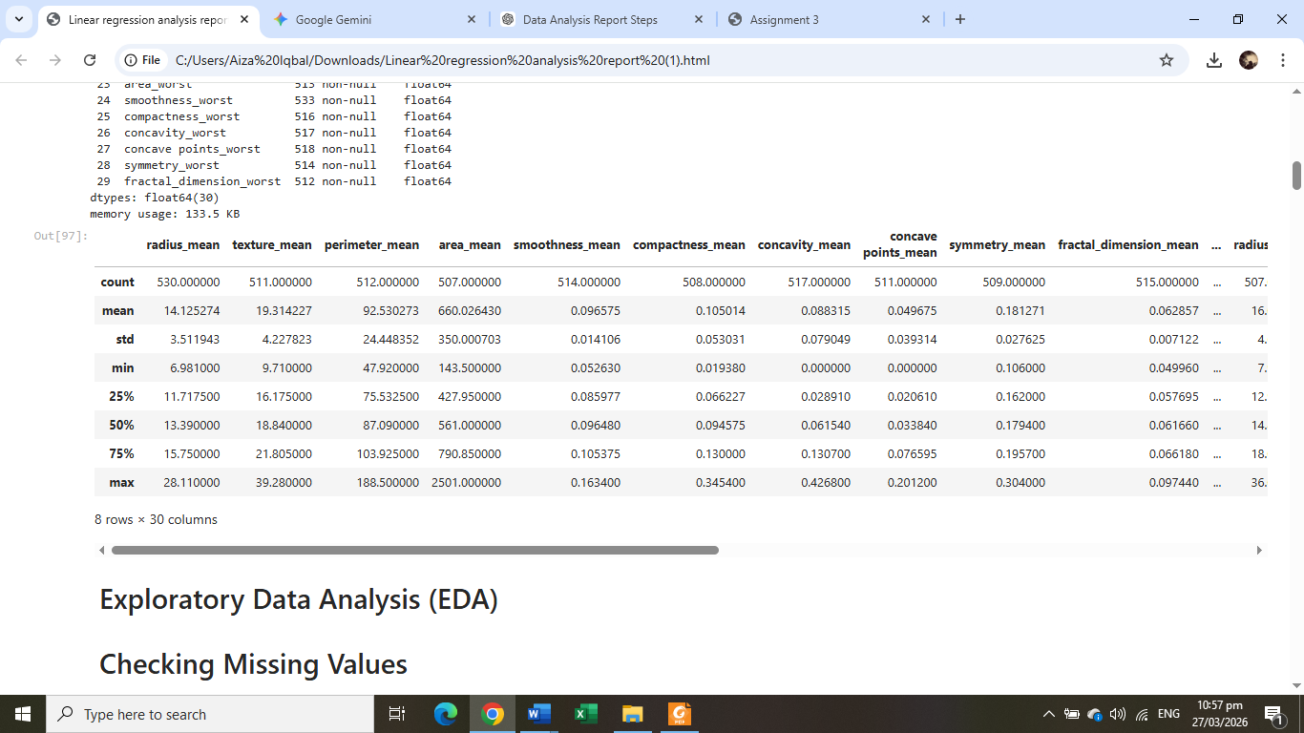
Python code:
df.shape
df.info()
df.describe()

Purpose:
• Identify dataset dimensions and structure
• Understand feature distributions
• Detect scale differences
• Prepare for Exploratory Data Analysis (EDA)

5. Exploratory Data Analysis (EDA):
Exploratory Data Analysis (EDA) was performed to explore patterns and relationships in the dataset.
- Summary statistics were analyzed.
- Data distribution and trends were examined.
- Relationships between variables were studied.
EDA helps in identifying patterns, detecting anomalies, and gaining insights that guide further analysis.
5.1 Feature Relationship Analysis (Correlation
Insight):
Correlation analysis was performed to understand how features relate to the target
variable.
Results showed strong relationships between several predictors and the target feature
(fractal_dimension_worst).
Highly Correlated Features
• compactness_worst → 0.81 correlation
• fractal_dimension_mean → 0.76
• concavity_worst → 0.68
• compactness_mean → 0.68

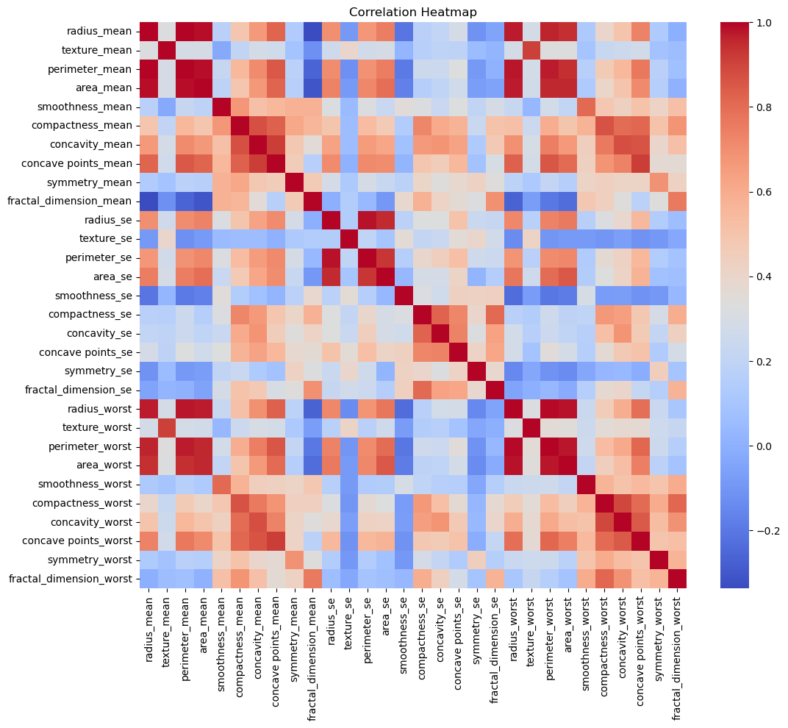

These values indicate strong influence on prediction outcomes.
Interpretation
• Highly correlated variables are strong predictors.
• Useful features can be selected for regression modeling.
• Weak correlations may contribute less to prediction accuracy
Python Code:
plt.figure(figsize=(12,10))
sns.heatmap(df.corr(), cmap="coolwarm")
plt.title("Correlation Heatmap")
plt.show()

5.2 Data Distribution Visualization:
Histograms were plotted to visualize the distribution of each feature. This helped in identifying whether the data follows a normal distribution or is skewed, which is important for model selection and preprocessing.

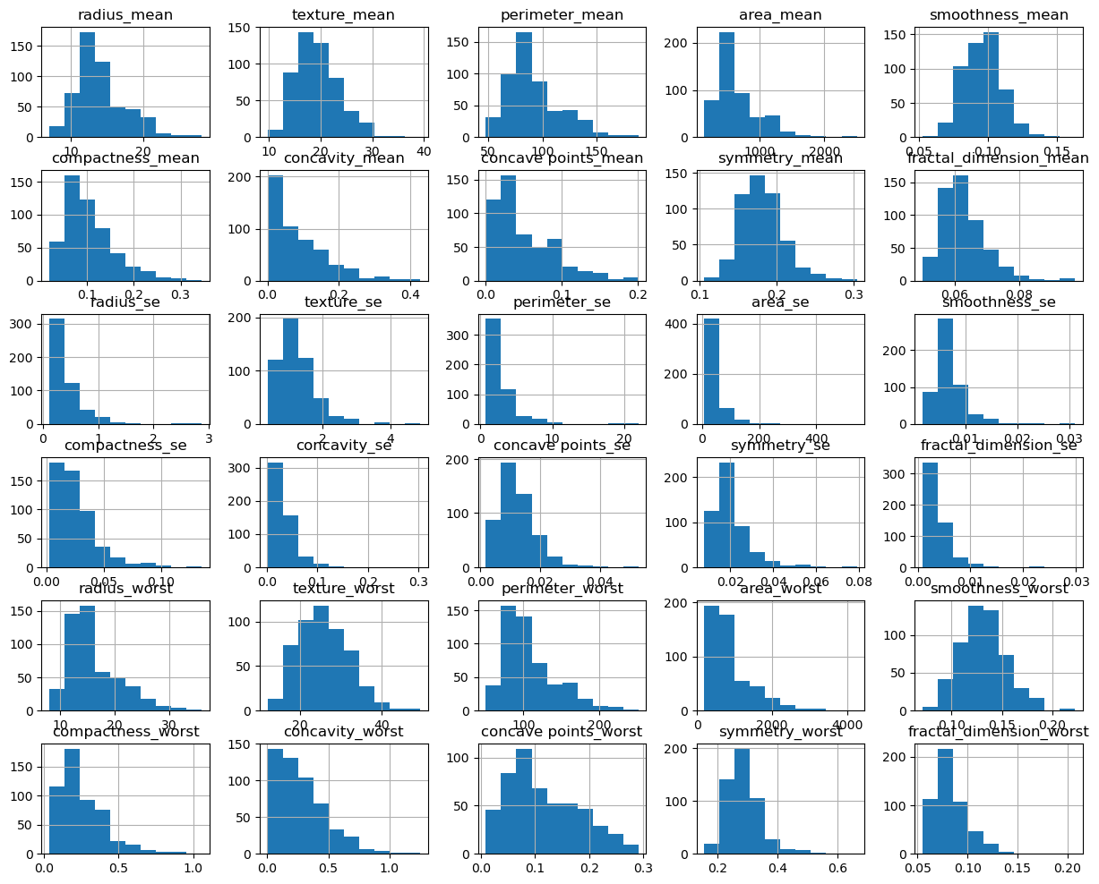
Observed Patterns
• Some features show normal distribution.
• Some features are right-skewed.
• Variation across features confirms need for normalization.
Importance of Distribution Analysis
• Detect skewness
• Identify outliers
• Understand data spread before modeling
Python Code:
df.hist(figsize=(15,12))
plt.show()

5.3 Outlier Detection:
Outlier detection was performed using statistical summaries and boxplots. Extreme values outside the normal range were identified. Although outliers can affect model performance, they were not removed in this analysis as they may represent meaningful variations in the dataset.

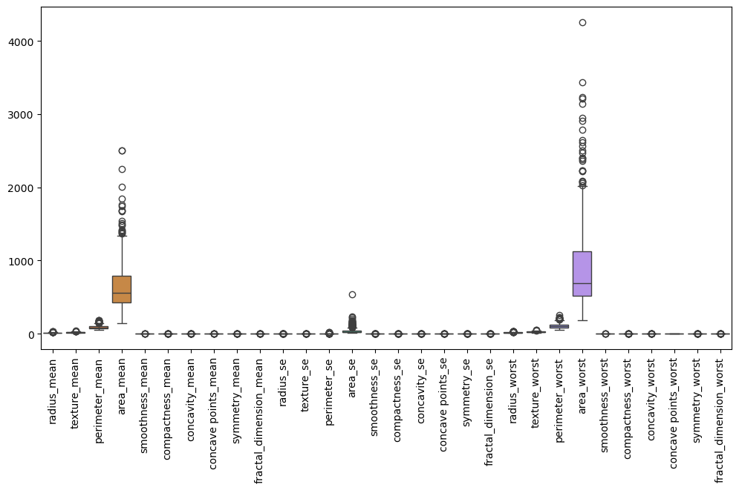
Python Code:
plt.figure(figsize=(12,6))
sns.boxplot(data=df)
plt.xticks(rotation=90)
plt.show()

Purpose:
• Ensure Data Quality
• Understand Data Behavior
• Support Better Decision Making
• Improve Model Accuracy

6. Data Cleaning & Preprocessing:
In this step, the dataset was prepared for analysis by handling missing values and ensuring data quality.
- A copy of the dataset was created (df_clean = df.copy()).
- Missing values were checked using df.isnull().sum().
- Missing values were filled using the mean of each column.
This step ensures that the dataset is clean and suitable for machine learning models.

6.1 Handling Missing Values:
During EDA, several columns were found to contain missing values. Missing data can
negatively affect model performance and produce biased results.
Therefore, missing values were handled during preprocessing to ensure a complete
dataset for analysis.
Columns | Missing  Values | Columns | Missing  Values
radius_mean | 39 | compactness_se | 54
texture_mean | 58 | concavity_se | 49
perimeter_mean | 57 | concave points_se | 64
area_mean | 62 | symmetry_se | 61
smoothness_mean | 55 | fractal_dimension_se | 41
compactness_mean | 61 | radius_worst | 62
concavity_mean | 52 | texture_worst | 63
concave points_mean | 58 | perimeter_worst | 52
symmetry_mean | 60 | area_worst | 56
fractal_dimension_mean | 54 | smoothness_worst | 36
radius_se | 64 | compactness_worst | 53
texture_se | 52 | concavity_worst | 52
perimeter_se | 47 | concave points_worst | 51
area_se | 61 | symmetry_worst | 55
smoothness_se | 42 | fractal_dimension_worst | 57

Python Code to Check Missing Values:
df.isnull().sum()

6.2 Mean Values of Every Column:
Mean values of every column are:
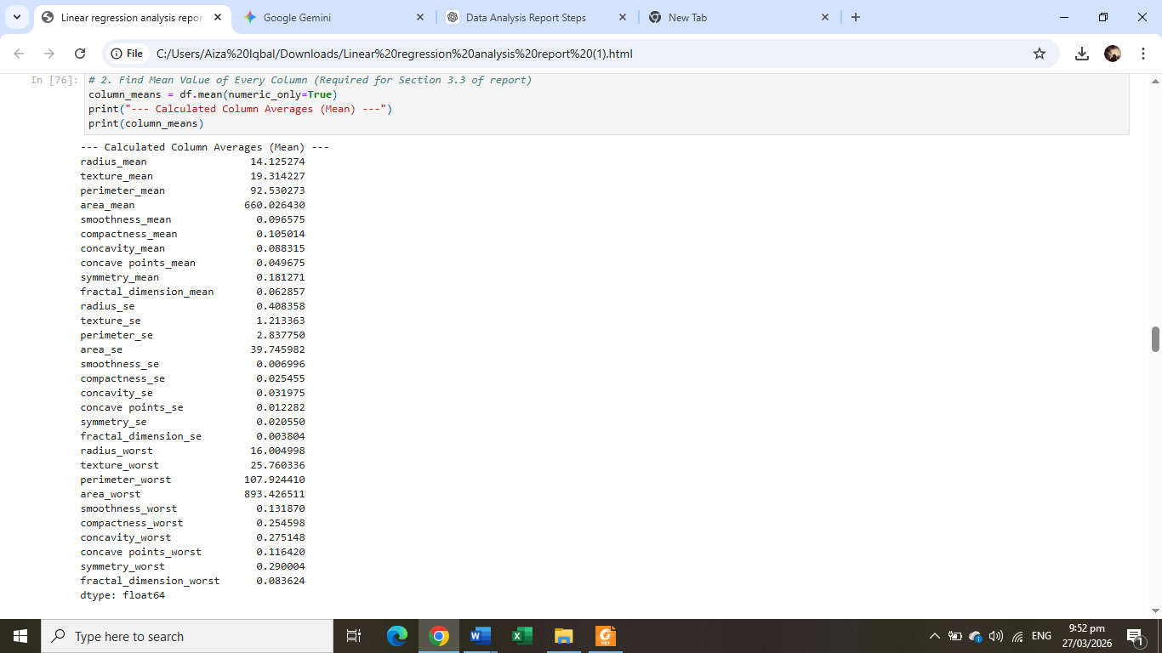
Python Code to Find Mean Values:
# 2. Find Mean Value of Every Column (Required for Section 3.3 of report)
column_means = df.mean(numeric_only=True)
print("--- Calculated Column Averages (Mean) ---")
print(column_means)

6.3 Filling Missing Values with Mean:
Missing values were filled using the mean of each column.

Python Code to Fill Missing Values:
#Fill null values with mean
df = df.fillna(df.mean())
# Verify again
print(df.isnull().sum())
print(df.head(5))

7. Feature & Target Selection:
Feature selection was performed to separate input and output variables.
- Independent variables (features) were stored in X.
- The target variable (last column) was stored in y.
This step is important because the model needs to know which variables to use for prediction.

Python Code:
# predict last column
X = df_clean.iloc[:, :-1]
y = df_clean.iloc[:, -1]

8. Data Normalization:
Data normalization was applied to scale the features.
- The StandardScaler was used to standardize the data.
- Training data was fitted and transformed.
- Test data was only transformed.
Normalization ensures that all features are on the same scale, which improves model performance and accuracy.

Python Code:
scaler = StandardScaler()
X_train = scaler.fit_transform(X_train)
X_test = scaler.transform(X_test)
9. Regression Model:
A Linear Regression model was applied to the dataset.
- The model was created using LinearRegression().
- The model was trained using training data (model.fit()).
This step allows the model to learn the relationship between input features and the target variable.

Python Code:
model = LinearRegression()
model.fit(X_train, y_train)
10. Prediction:
After training, the model was used to make predictions.
- Predictions were generated using model.predict(X_test).
This step provides the estimated values of the target variable based on the learned model.

Python Code:
y_pred = model.predict(X_test)

11. Error Report:
The performance of the model was evaluated using different error metrics:

- MSE (Mean Squared Error): Measures the average of the squares of the errors. It heavily penalizes larger errors. (Score: 6.021755330668126e-05)
- MAE (Mean Absolute Error): The average of the absolute difference between the predicted and actual values. It provides a linear score of accuracy. (Score: 0.0046671772069175705)
- RMSE (Root Mean Squared Error): The square root of MSE, which converts the error back into the original units of the target variable. (Score: 0.007759996991409291)
- $R^2$ Score (Coefficient of Determination): Represents the proportion of variance for the target that is explained by the features. (Score: 0.821 or 82.1%)
These metrics help in understanding how well the model is performing.

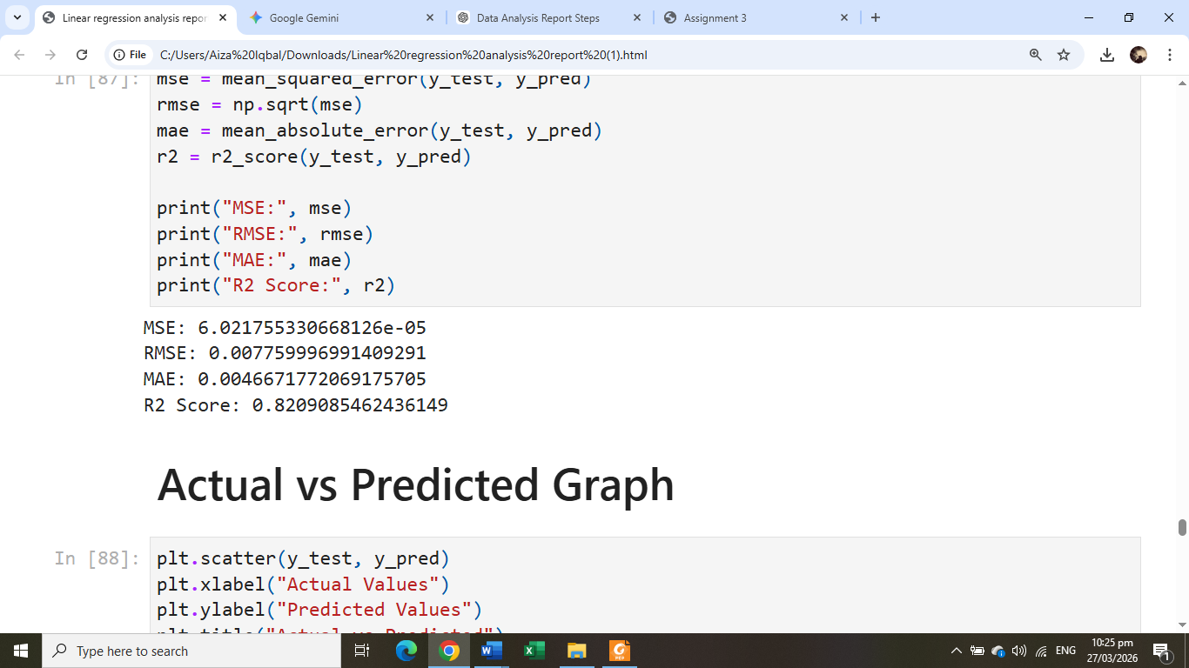

Python Code:
mse = mean_squared_error(y_test, y_pred)
rmse = np.sqrt(mse)
mae = mean_absolute_error(y_test, y_pred)
r2 = r2_score(y_test, y_pred)

print("MSE:", mse)
print("RMSE:", rmse)
print("MAE:", mae)
print("R2 Score:", r2)
12. Actual vs Predicted Graph:
The actual vs predicted analysis was performed to evaluate the performance of the regression model. The predicted values obtained from the model were compared with the actual values from the dataset. A scatter plot was used to visualize the relationship between actual and predicted values. Ideally, the points should lie close to a diagonal line, indicating accurate predictions. In this analysis, the model showed reasonable alignment between actual and predicted values, indicating satisfactory performance.

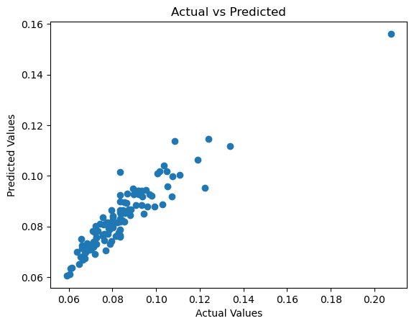
Python Code:
plt.scatter(y_test, y_pred)
plt.xlabel("Actual Values")
plt.ylabel("Predicted Values")
plt.title("Actual vs Predicted")
plt.show()
Purpose:
- To check how close predictions are to real values
- To measure model accuracy
- To identify errors in prediction

13. Predictive Analysis:
Predictive analysis was performed to understand feature importance.
- Model coefficients were analyzed.
- Features with higher coefficients have a greater impact on predictions.
This step helps identify the most influential variables in the dataset.

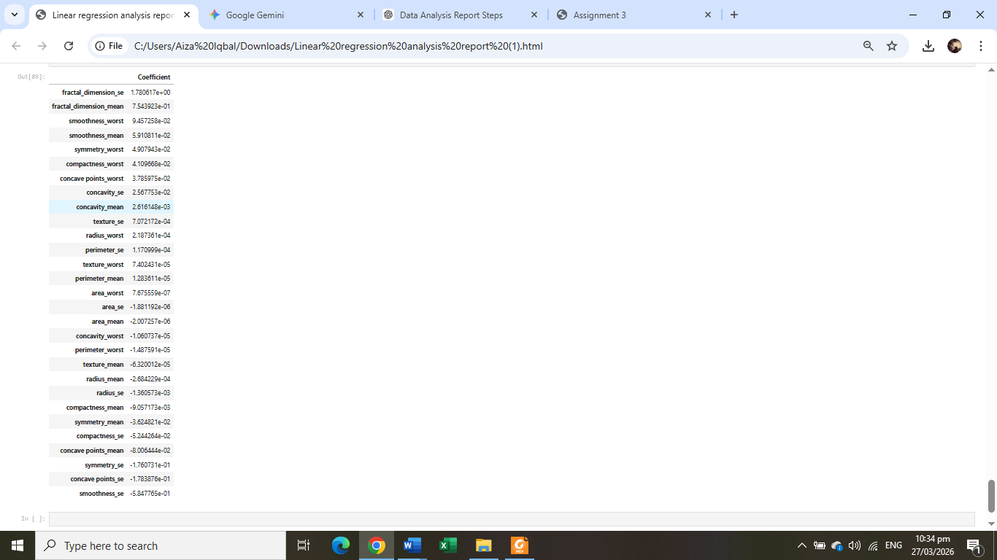
Python Code:
importance = pd.DataFrame(
model.coef_,
X.columns,
columns=["Coefficient"]
)
importance.sort_values(by="Coefficient", ascending=False)
14. Conclusion:
The analysis successfully followed all steps from data loading to prediction.
- The dataset was cleaned and prepared properly.
- A Linear Regression model was applied.
- The model produced predictions with reasonable accuracy.
- Important features influencing the target variable were identified.
Overall, the project demonstrates how data analysis and machine learning can be used to extract insights and make predictions.

